**PROFESSIONAL READINESS FOR INNOVATION, EMPLOYABILITY AND ENTREPRENEURSHIP**

# PROJECT REPORT FOR WEEK 7

**Project Tile**: AI-powered Nutrition Analyzer for Fitness Enthusiasts

**Team ID:** PNT2022TMID48053

**GitHub ID:** IBM-Project-53441-1665376120

**WEEK 7(06-08 Oct 2022):**

In week 7, We had Prepared the Customer journey maps which gives details about various phases,steps,feelings,painpoints,opportunities associated with our project.We attended the technology training sessions.We had completed the Assignment-4 and uploaded it in our github account.

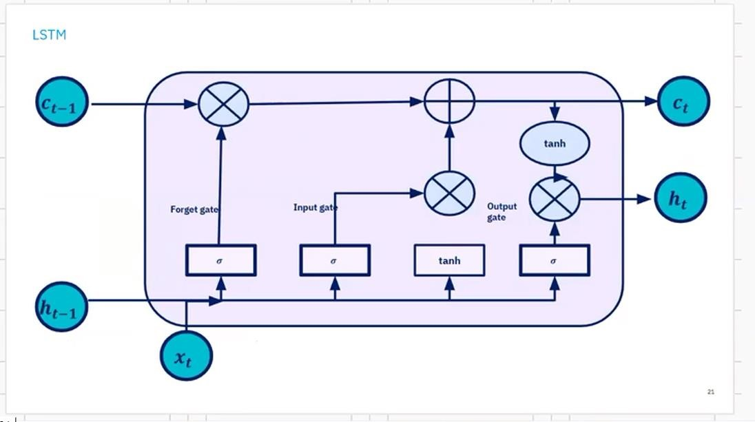

**Virtual Assistants:**

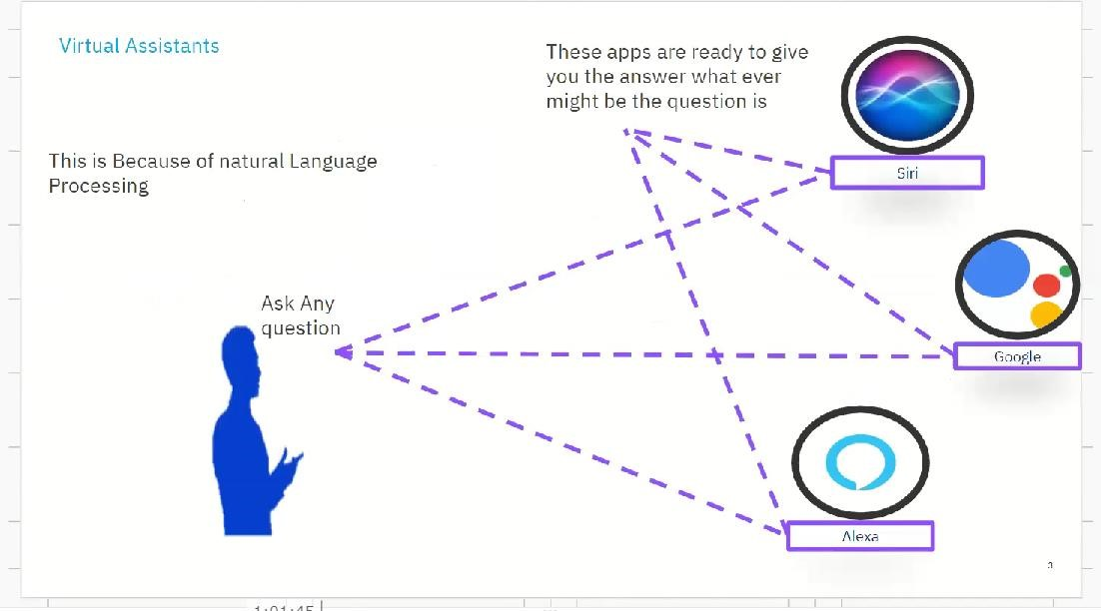

**Natural Language Processing:**

